APS-Swing/Slide Mat 40” x 40” x 1 ½” Swing/Slide Wear Mat
Dimensions: 40” x 40” x 1 1/2”
Manufacturing: 100% compressed rubber
Weight: 64# each

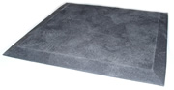
Beveled Edges

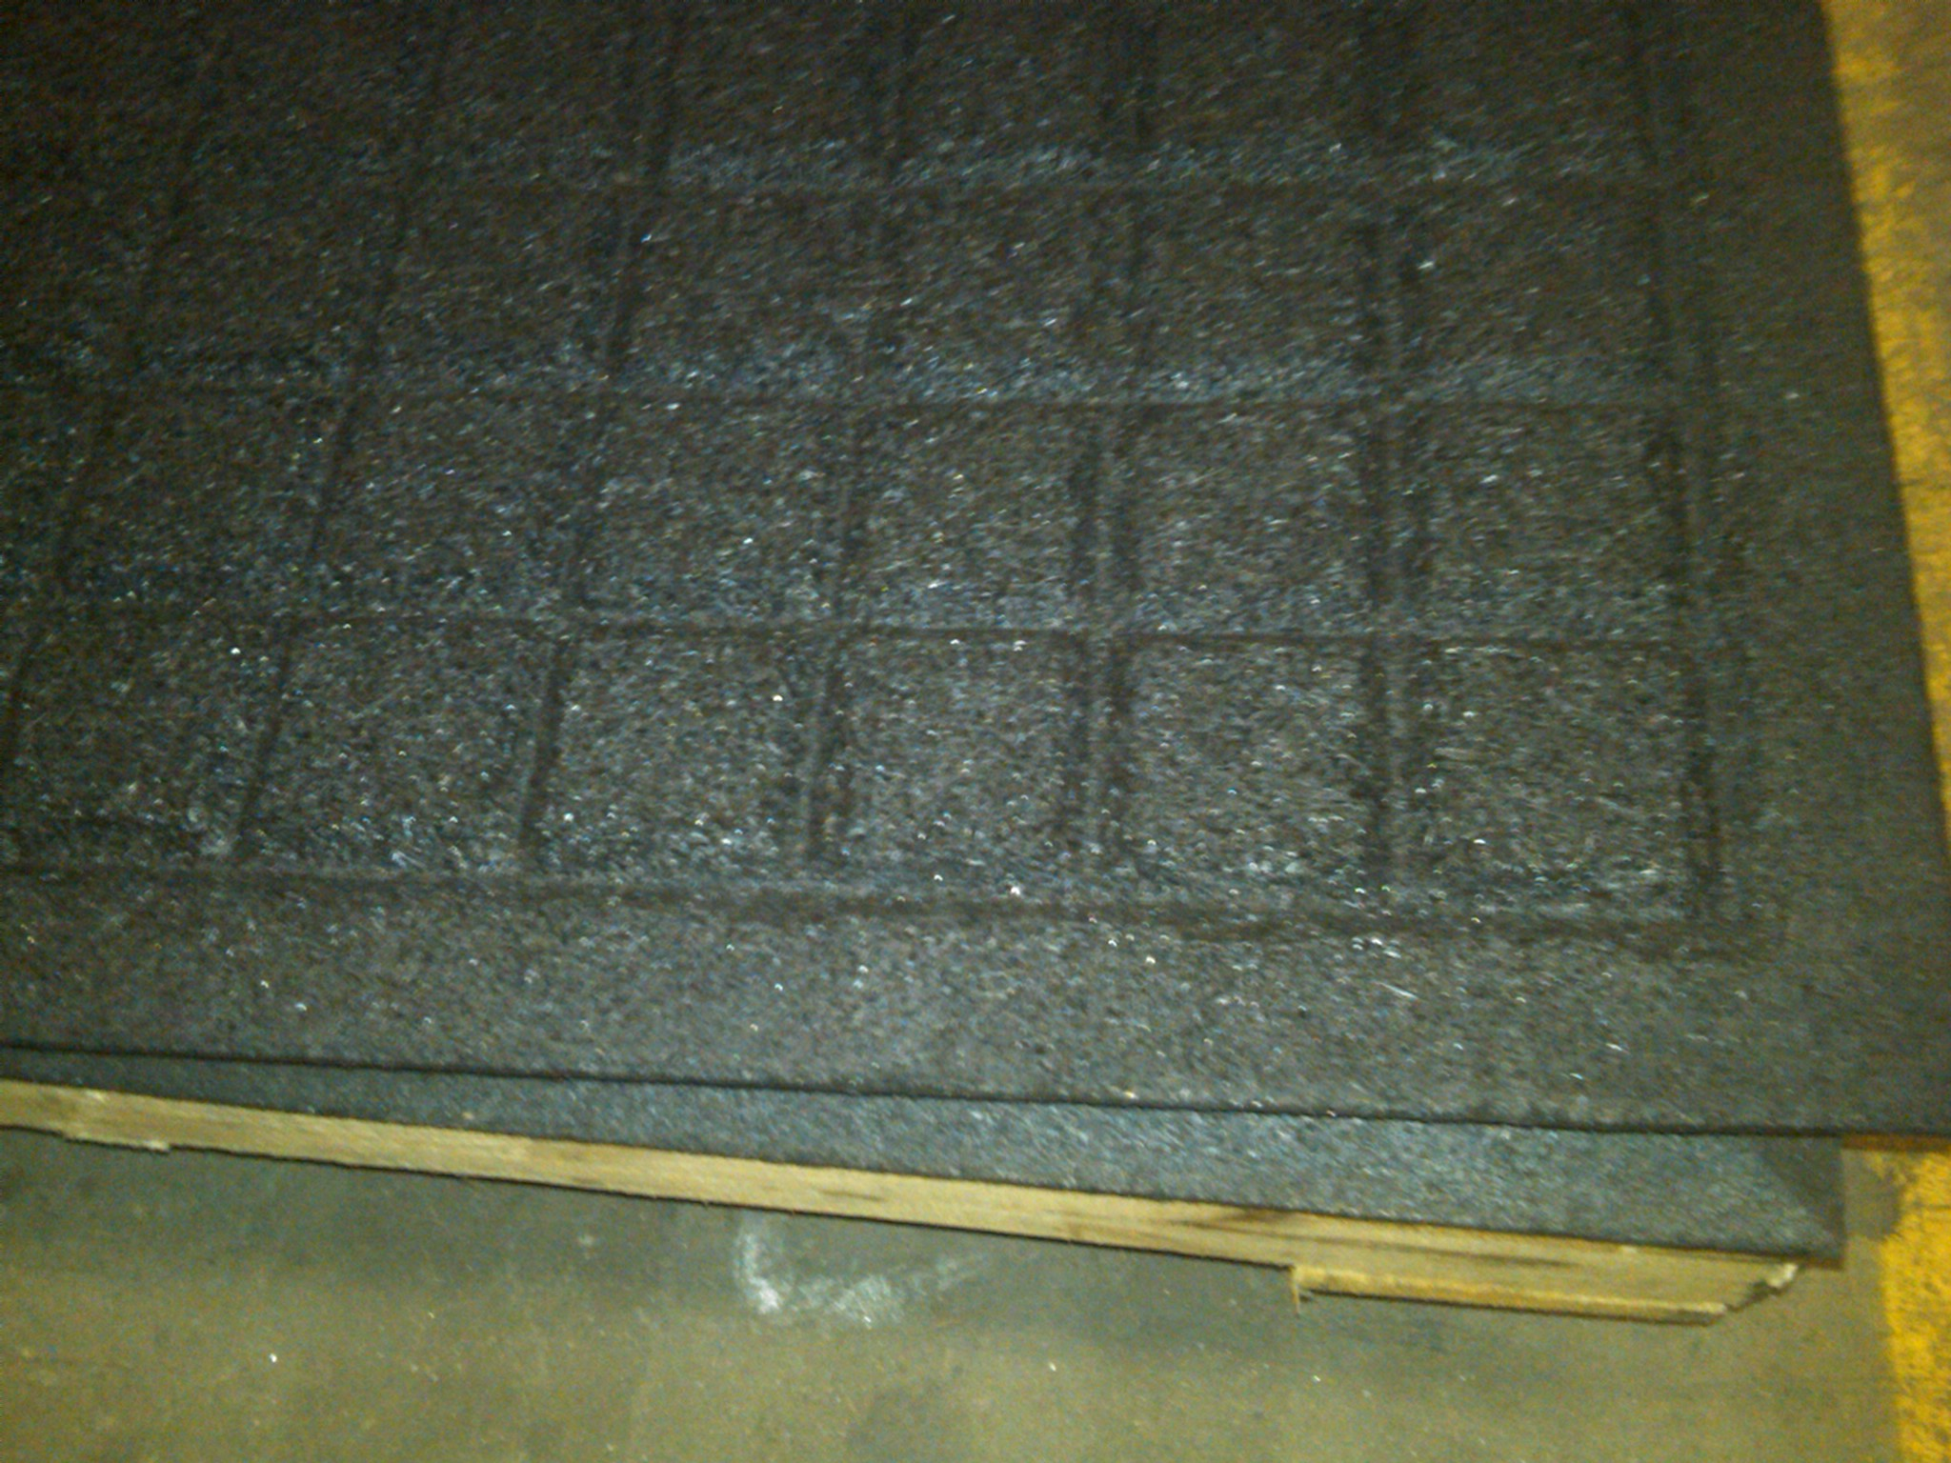

“WAFFLE” pattern on bottom for stability

